SKILL-12
- To Create Pipes, Redirect Streams, Execute Connected Commands, Close Descriptors, Synchronize Processes, Test Data Flow.
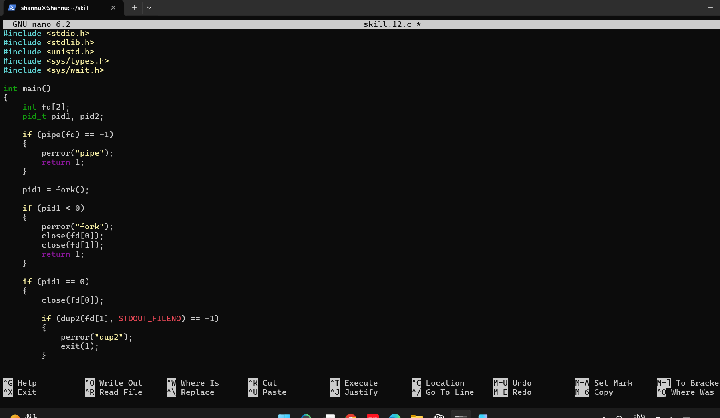
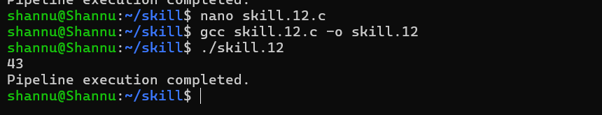

To Support Multiple Pipes, Manage Descriptor Arrays, Launch Multiple Processes, Coordinate Execution, Cleanup Resources, Test Long Pipelines.
